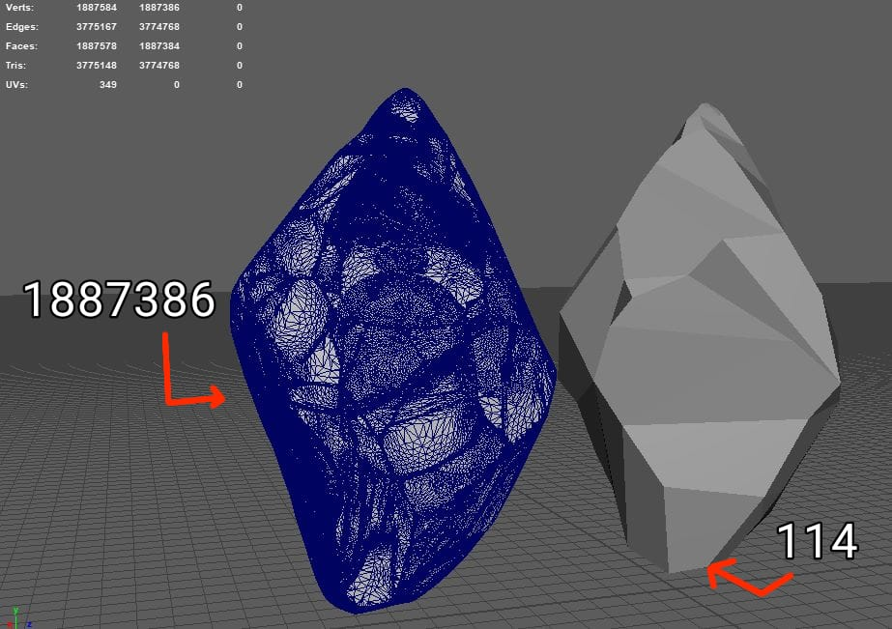

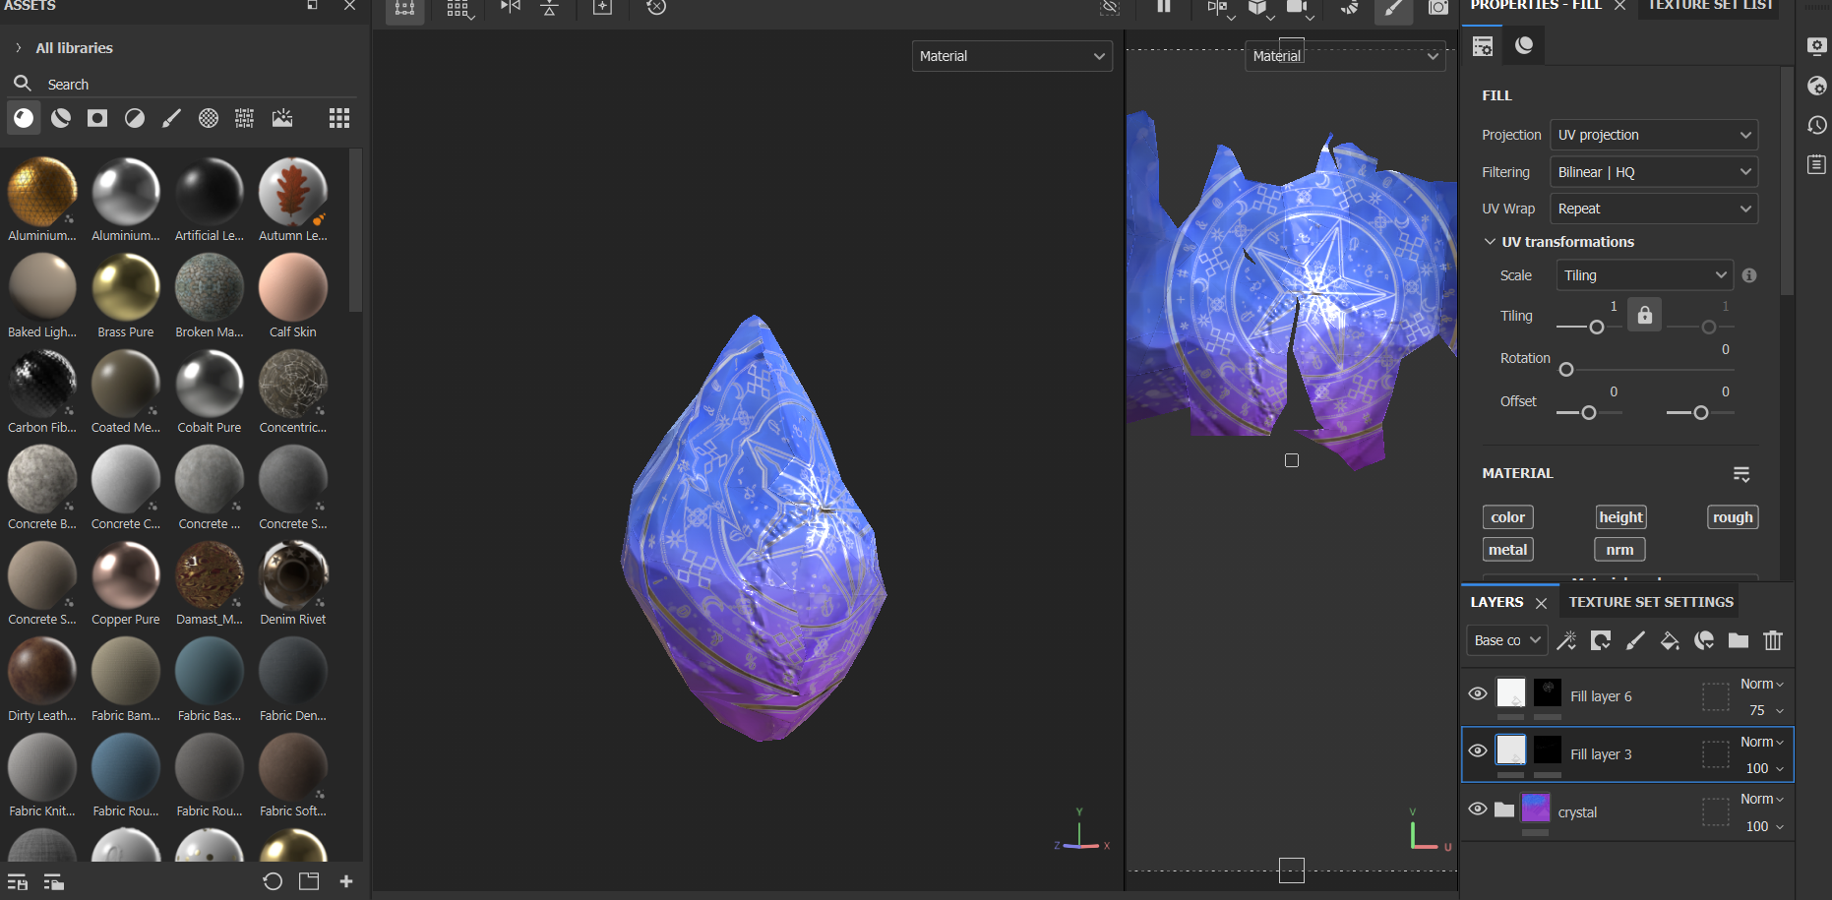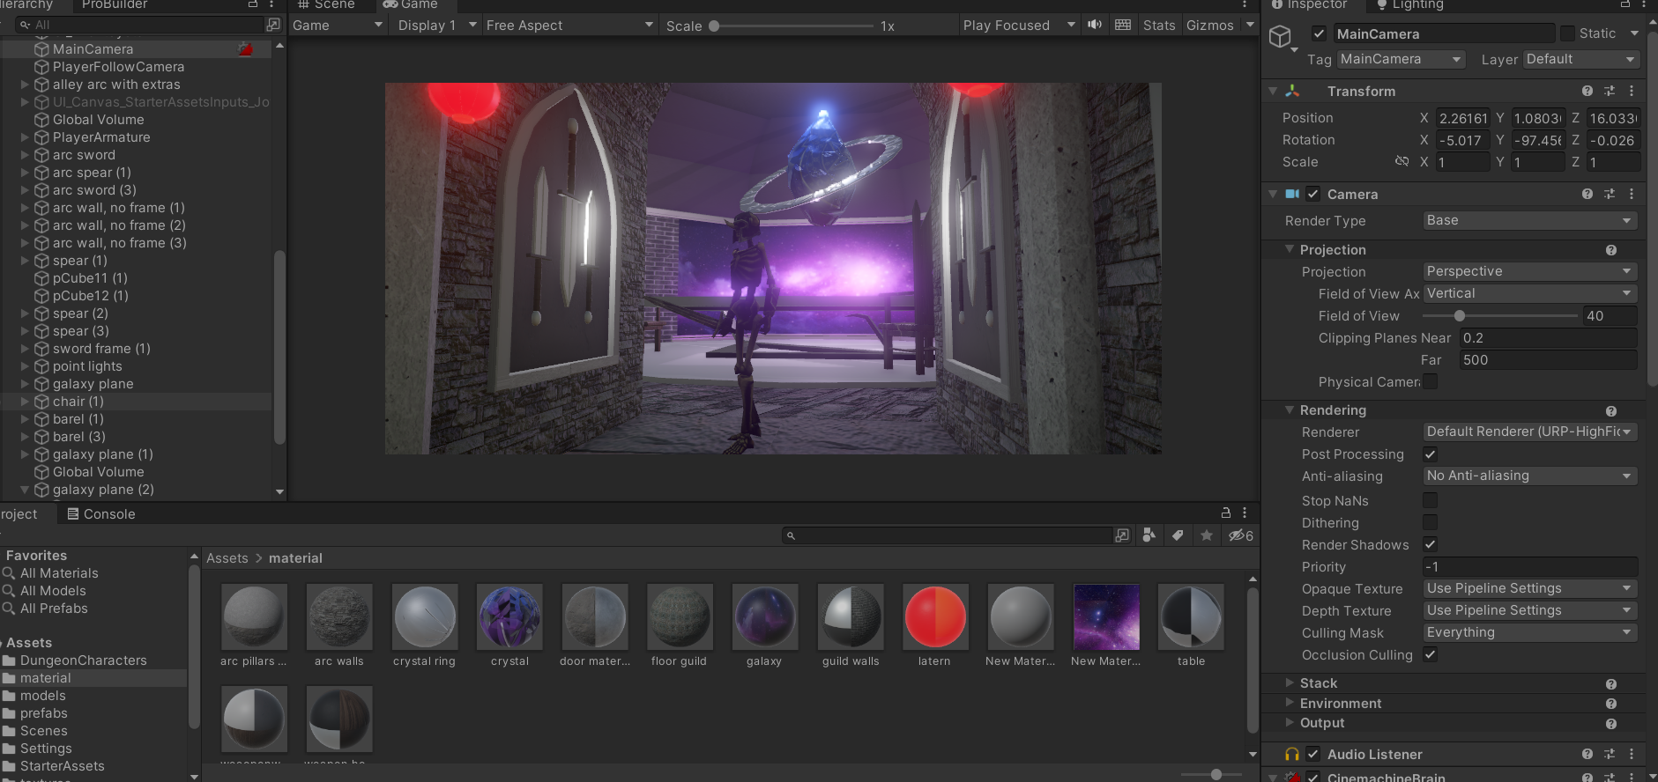

<https://pngtree.com/freepng/circular-star-rune-luminous-effect-psd-transparent-bottom_7416686.html>

<https://www.dreamstime.com/vikings-runes-pagan-futhark-odin-mythology-nordic-thor-algiz-myth-runes-pagan-futhark-odin-mythology-image162828082>

<https://guidetoiceland.is/history-culture/a-guide-to-icelandic-runes>

<https://substance3d.adobe.com/community-assets/assets/d4fac368de6c0e5a8cd76c715be3a71897b8d3cc>

<https://substance3d.adobe.com/community-assets/assets/f1e61a7dd017fca4b7dd2b14298ce637660e2e23>

<https://substance3d.adobe.com/community-assets/assets/14fb5acfc679523f45d5b223eee64b45b5341ecd>

<https://substance3d.adobe.com/community-assets/assets/1ec8f79b0335ab2a011c0bf09ea14f80c6a47e13>

<https://substance3d.adobe.com/community-assets/assets/1bed9d73d78d3e5510d17adc038b6b7bf4631b36>

<https://www.youtube.com/watch?v=ffDgbyisuII&t=323s>